ADLC Limitation: -

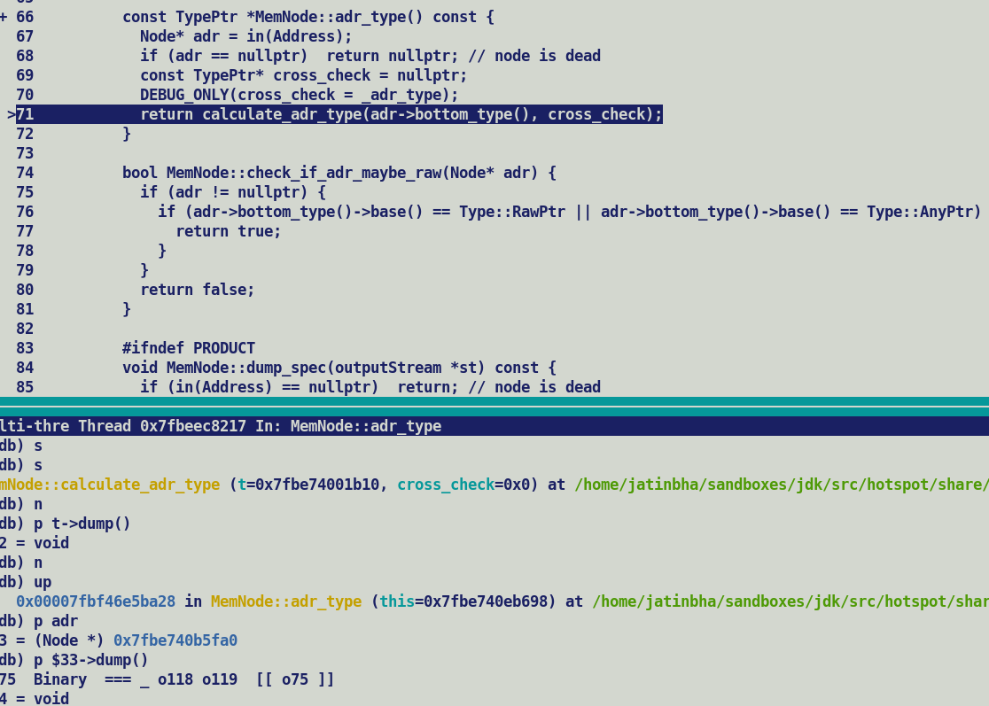

Address type computation involving synthetic binary nodes.

